# Lab 1 Tutor’s Guide

## Data-Driven Decision Making

## Introduction

In this practical, we will learn the following:

* How to use the TreePlan to construct a decision tree
* How to recommend decision without probabilities : using optimistic, conservative and minimax regret approaches
* How to recommend decision using probabilities: the expected value approach

##### Task 1 – Construct a simple decision tree using TreePlan in Microsoft Excel

Download the TreePlan Guide-179 document from BB and construct the DriveTek Decision Tree Diagram as shown below. The step-by-step instructions are given from page 191 to 199.

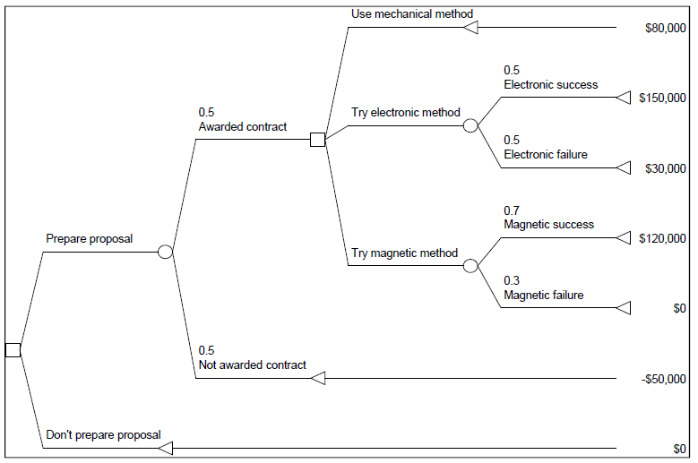

##### Task 2 – Decision Tree

The following payoff table shows profit for a decision analysis problem with two decision alternatives and three states of nature:

|  |  |  |  |
| --- | --- | --- | --- |
|  | State of nature | | |
| Decision Alternatives | S1 | S2 | S3 |
| D1 | 250 | 100 | 25 |
| D2 | 100 | 100 | 75 |

If the decision maker knows nothing about probabilities of the three states of nature, what is the recommended decision using the optimistic (MAXIMAX), conservative (MAXIMIN) and minimax regret approaches? Use Excel to create a worksheet with formulae to help you answer this question.

|  |  |  |
| --- | --- | --- |
| Decision Alternatives | Maximum Profit | Minimum Profit |
| D1 | 250 | 25 |
| D2 | 100 | 75 |

Optimistic approach: select D1

Conservative approach: select D2

Regret or Opportunity Loss Table with the Maximum Regret:

|  |  |  |  |  |
| --- | --- | --- | --- | --- |
|  | S1 | S2 | S3 | Maximum Regret |
| D1 | 0 | 0 | 50 | 50 |
| D2 | 150 | 0 | 0 | 150 |

##### Task 3 – Decision Tree and Expected Value approach

Using the same scenario in Task 2, the decision maker obtained the probability assessments P(S1)=0.65, P(S2)=0.15 and P(S3)=0.20. Create a decision tree using TreePlan and use the expected value approach to determine the optimum decision.

EV(D1) = 0.65(250) + 0.15(100) + 0.20(25) = 182.5

EV(D2) = 0.65(100) + 0.15(100) + 0.20(75) = 95

Optimum decision is to select D1.

##### Task 4 – Expand or move

A department store, Carrefull, has to decide whether to expand on its existing site in the town centre or to move to a new site on the outskirts. There is a possibility that a rival store by a rival company called Sparks & Mencer (S&M), may open a branch in the town centre in the near future. If S&M does open a branch, the Carrefull’s total profit will be $10mil if it does not move, as against $16mil if Carrefull does move.

If the S&M branch does not open, the total profits for Carrefull at the town centre site are estimated at $40mil and for the new site, at $32mil. The probability of the S&M rival branch opening is estimated to be about 70%. Construct a decision trees for this case and recommend the decision that would maximize expected profit.

The decision tree is as shown below.

Recommendation: Move to the new site (as it offers $20.8mil in profit whereas expanding the store only offers $19mil profit)

